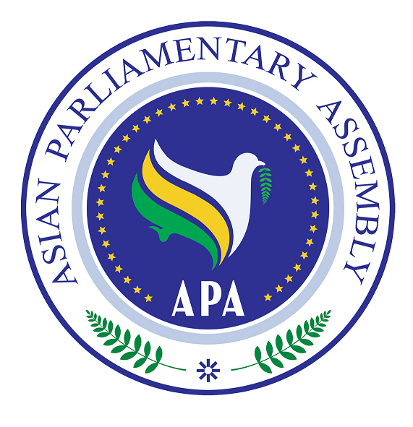
Asian Parliamentary Assembly (APA)

REGISTRATION FORM
Coordinating Meeting of Asian Parliamentary Assembly
On the sideline of 140th IPU Assembly
Sheraton Convention Center
Salwa2 Hall
Saturday 6 April 2019 – 09:30- 11:00 am

Please fill in one registration form for each participant (in block capitals) and return it to APA Secretariat at the following address by Feb. 20, 2019 at the latest.
- Delegation of: …………

- Title: Please check Mr. Ms. Dr. other
- First Name:
- Last Name:

- Position in the parliament
……………………………………………………………………………………

- Phone No. | - …………………..……………………………………………..  - Country Code City Code Number
- Cell phone  - Fax No. | - …………………………………………………………………  - ………………………………………………………………..
- Email Address: | - ……………….……………………………………………..

Any Proposal on Emergency Item:

